PLAGIARISM DETECTOR
A
MAJOR PROJECT REPORT
Submitted for the partial fulfilment of the requirement for the award of
Degree of
BACHELOR OF TECHNOLOGY
IN
COMPUTER SCIENCE & ENGINEERING



Submitted By: Guided By:
NAINAN DUBEY (0101CS181068)
Prof. RAJEEV PANDEY
Prof. MANISH MISHRA
UTKARSH GAUTAM (0101CS181118)
SUNNY MUNJEWAR (0101CS181111)
SAQIB FAYAZ (0101CS181099)

DEPARTMENT OF COMPUTER SCIENCE & ENGINEERING
UNIVERSITY INSTITUTE OF TECHNOLOGY
RAJIV GANDHI PROUDYOGIKI VISHWAVIDALAYA
BHOPAL-462033
SESSION 2018-2022

RAJIV GANDHI PROUDYOGIKI VISHWAVIDALAYA
DEPARTMENT OF COMPUTER SCIENCE & ENGINEERING

CERTIFICATE

This is to certify that Nainan Dubey, Utkarsh Gautam, Sunny Munjewar, Saqib Fayaz of B.Tech Fourth Year, Computer Science & Engineering have completed their Major Project entitled “Plagiarism Detector ” during the year 2021-2022 under our guidance and supervision.
We approve the project for the submission for the partial fulfilment of the requirement for the award of the degree of B.Tech in Computer Science & Engineering.

Prof. RAJEEV PANDEY
Project Guide
Prof. MANISH MISHRA
Project Guide

Dr. Roopam Gupta HOD CSE
UIT RGPV BHOPAL

DECLARATION

We hereby declare that the work which is being presented in this Major Project entitled “Plagiarism Detector” Submitted to University Institute of Technology, RGPV in the partial fulfilment of the requirements for the award of the degree of BACHELOR OF TECHNOLOGY in COMPUTER SCIENCE AND ENGINEERING. The work has carried out at University Institute of Technology, RGPV Bhopal is an authentic record of our work under the supervision of Prof. Rajeev Pandey and Prof. Manish Mishra Department of Computer Science and Engineering, UIT- RGPV, Bhopal.
The matter of this project has not been submitted by us for the award of any other degree or professional diploma.

NAINAN DUBEY (0101CS181068)
UTKARSH GAUTAM (0101CS181118)
SUNNY MUNJEWAR (0101CS181111)
SAQIB FAYAZ (0101CS181099)

ACKNOWLEDGMENT

We wish to express our significant and true appreciation to Prof. Rajeev Pandey and Prof. Manish Mishra Department of Computer Science And Engineering, University Institute Of Technology Rajeev Gandhi Prodyogiki Viswavidyalaya who guided us into the complexity of the project with incomparable generosity. They likewise revealed unmistakable fascination and significant help in the field of Machine Learning and the advancement of our task work.

Abstract

This project proposes a way to control the position of the cursor with the bare hands without using any electronic device. While the operations like clicking and dragging of objects will be performed with different hand gestures. The proposed system will only require a webcam as an input device. The software's that will be required to implement the proposed system are OpenCV and python. The output of the camera will be displayed on the system's screen so that it can be further calibrated by the user. The python dependencies that will be used for implementing this system are Mediapipe, math, wx and mouse.
The Virtual Mouse discussed in the research paper only included the idea of left click and right click after analyzing the various research paper we added the functionality of scroll up and scroll down, double click, brightness control, volume control and drag and drop.
Our project start it’s modelling by first resizing the image using camera coordinates after this it separate the hand area from a complex background. An Image Morphology Algorithm is used to delete the noisy pixel. In the next step the Convex Hull Algorithm is used to find the fingertip. We used pyautogui library that allows mouse and keyboard controls after performing all this the right event is invoked to perform the respective function.

Table of Contents

CHAPTER 1. INTRODUCTION……………………………………………8-9

CHAPTER 2. LITERATURE SURVEY…………………………………….10-17

CHAPTER 3. PROBLEM STATEMENT …..………………………………..17

CHAPTER 4. PROPOSED WORK …………………………….…………...18-23

CHAPTER 5. IMPLEMENTATION……………...………………………….24-30

CHAPTER 6 RESULT AND ANALYSIS……………………………………31-34

CHAPTER 7. CONCLUSION ………………………...…...………………….35-36

CHAPTER 8. BIBLIOGRAPHY……………………………...………………..37

LIST OF FIGURES

S No. | Description | Page No.
1. |  | 13
2. |  | 20
3. |  | 24
4. |  | 25
5. |  | 27
6. |  | 30
7. |  | 31
8. |  | 32
9. |  | 33

INTRODUCTION

Plagiarism detection or content similarity detection is the process of locating instances of plagiarism and/or copyright infringement within a work or document. The widespread use of computers and the advent of the Internet have made it easier to plagiarize the work of others.

Detection of plagiarism can be undertaken in a variety of ways. Human detection is the most traditional form of identifying plagiarism from written work. This can be a lengthy and time-consuming task for the reader and can also result in inconsistencies in how plagiarism is identified within an organization.

Plagiarism in computer source code is also frequent, and requires different tools than those used for text comparisons in documents. Significant research has been dedicated to academic source-code plagiarism. A distinctive aspect of source-code plagiarism is that there are no essay mills, such as can be found in traditional plagiarism. Since most programming assignments expect students to write programs with very specific requirements, it is very difficult to find existing programs that already meet them. Since integrating external code is often harder than writing it from scratch, most plagiarizing students choose to do so from their peers.
According to Roy and Cordy, source-code similarity detection algorithms can be classified as based on either
- Strings – look for exact textual matches of segments, for instance five-word runs. Fast, but can be confused by renaming identifiers.

- Tokens – as with strings, but using a lexer to convert the program into tokens first. This discards whitespace, comments, and identifier names, making the system more robust to simple text replacements. Most academic plagiarism detection systems work at this level, using different algorithms to measure the similarity between token sequences.

- Parse Trees – build and compare parse trees. This allows higher-level similarities to be detected. For instance, tree comparison can normalize conditional statements, and detect equivalent constructs as similar to each other.

- Program Dependency Graphs (PDGs) – a PDG captures the actual flow of control in a program, and allows much higher-level equivalences to be located, at a greater expense in complexity and calculation time.

- Metrics – metrics capture 'scores' of code segments according to certain criteria; for instance, "the number of loops and conditionals", or "the number of different variables used". Metrics are simple to calculate and can be compared quickly, but can also lead to false positives: two fragments with the same scores on a set of metrics may do entirely different things.

- Hybrid approaches – for instance, parse trees + suffix trees can combine the detection capability of parse trees with the speed afforded by suffix trees, a type of string-matching data structure.

The previous classification was developed for code refactoring, and not for academic plagiarism detection (an important goal of refactoring is to avoid duplicate code, referred to as code clones in the literature).
The above approaches are effective against different levels of similarity; low-level similarity refers to identical text, while high-level similarity can be due to similar specifications. In an academic setting, when all students are expected to code to the same specifications, functionally equivalent code (with high- level similarity) is entirely expected, and only low-level similarity is considered as proof of cheating.

LITERATURE SURVEY
Machine learning is a method of data analysis that automates analytical model building. It is a branch of artificial intelligence based on the idea that systems can learn from data, identify patterns and make decisions with minimal human intervention.
the study of computer algorithms that improve automatically through experience. It is seen as a part of artificial intelligence. Machine learning algorithms build a model based on sample data, known as "training data", in order to make predictions or decisions without being explicitly programmed to do so.Machine learning algorithms are used in a wide variety of applications, such as email filtering and computer vision, where it is difficult or unfeasible to develop conventional algorithms to perform the needed tasks.
A subset of machine learning is closely related to computational statistics, which focuses on making predictions using computers; but not all machine learning is statistical learning. The study of mathematical optimization delivers methods, theory and application domains to the field of machine learning. Data mining is a related field of study, focusing on exploratory data analysis through unsupervised learning.In its application across business problems, machine learning is also referred to as predictive analytics.

sys Library : This module provides access to some variables used or maintained by the interpreter and to functions that interact strongly with the interpreter. It is always available.

ast library : The ast module helps Python applications to process trees of the Python abstract syntax grammar. The abstract syntax itself might change with each Python release; this module helps to find out programmatically what the current grammar looks like.
An abstract syntax tree can be generated by passing ast.PyCF_ONLY_AST as a flag to the compile() built-in function, or using the parse() helper provided in this module. The result will be a tree of objects whose classes all inherit from ast.AST. An abstract syntax tree can be compiled into a Python code object using the built-in compile() function.
difflib library: This module provides classes and functions for comparing sequences. It can be used for example, for comparing files, and can produce information about file differences in various formats, including HTML and context and unified diffs. For comparing directories and files, see also, the filecmp module.

Operator library: The operator module exports a set of efficient functions corresponding to the intrinsic operators of Python. For example,operator.add(x,y) is equivalent to the expression+y Many function names are those used for special methods, without the double underscores. For backward compatibility, many of these have a variant with the double underscores kept. The variants without the double underscores are preferred for clarity.
The functions fall into categories that perform object comparisons, logical operations, mathematical operations and sequence operations.

The object comparison functions are useful for all objects, and are named after the rich comparison operators they support:

operator.lt(a, b) operator.le(a, b) operator.eq(a, b) operator.ne(a, b) operator.ge(a, b)
operator.gt(a, b) operator. lt (a, b) operator. le (a, b) operator. eq (a, b) operator. ne (a, b) operator. ge (a, b) operator. gt (a, b)

Argparse library: The argparse module makes it easy to write user-friendly command-line interfaces. The program defines what arguments it requires, and argparse will figure out how to parse those out of sys.argv. The argparse module also automatically generates help and usage messages and issues errors when users give the program invalid arguments.
Itrtools : This module implements a number of iterator building blocks inspired by constructs from APL, Haskell, and SML. Each has been recast in a form suitable for Python.
The module standardizes a core set of fast, memory efficient tools that are useful by themselves or in combination. Together, they form an “iterator algebra” making it possible to construct specialized tools succinctly and efficiently in pure Python.
For instance, SML provides a tabulation tool:tabulate(f) which produces a sequence f(0),f(1),… The same effect can be achieved in Python by combining map() and count() to formmap(f,count())
These tools and their built-in counterparts also work well with the high-speed functions in the operator module. For example, the multiplication operator can be mapped across two vectors to form an efficient dot-product:sum(map(operator.mul, vector1, vector2)).

Computer-assisted plagiarism detection (CaPD) is an Information retrieval (IR) task supported by specialized IR systems, which is referred to as a plagiarism detection system (PDS) or document similarity detection system. A 2019 systematic literature review presents an overview of state-of-the-art plagiarism detection methods.

IN TEXT DOCUMENTS

Systems for text similarity detection implement one of two generic detection approaches, one being external, the other being intrinsic.External detection systems compare a suspicious document with a reference collection, which is a set of documents assumed to be genuine. Based on a chosen document model and predefined similarity criteria, the detection task is to retrieve all documents that contain text that is similar to a degree above a chosen threshold to text in the suspicious document. Intrinsic PDSes solely analyze the text to be evaluated without performing comparisons to external documents. This approach aims to recognize changes in the unique writing style of an author as an indicator for potential plagiarism. PDSes are not capable of reliably identifying plagiarism without human judgment. Similarities and writing style features are computed with the help of predefined document models and might represent false positives.

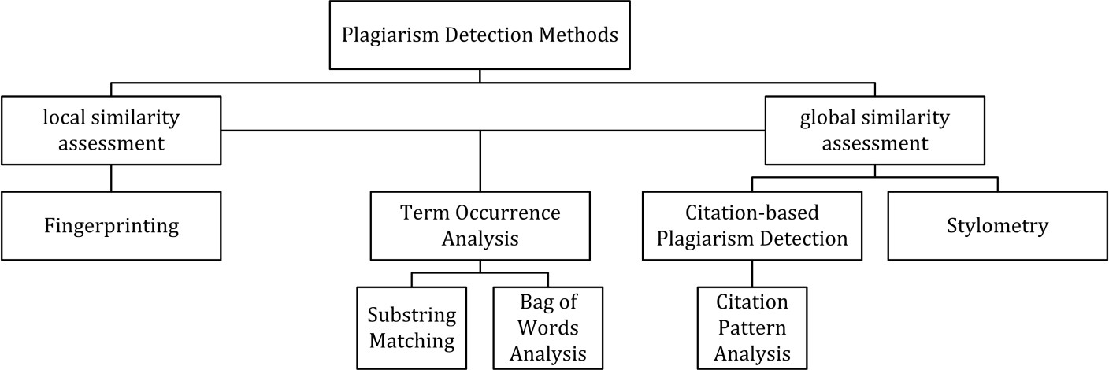

FINGERPRINTING
Fingerprinting is currently the most widely applied approach to content similarity detection. This method forms representative digests of documents by selecting a set of multiple substrings (n-grams) from them. The sets represent the fingerprints and their elements are called minutiae. A suspicious document is checked for plagiarism by computing its fingerprint and querying minutiae with a precomputed index of fingerprints for all documents of a reference collection. Minutiae matching with those of other documents indicate shared text segments and suggest potential plagiarism if they exceed a chosen similarity threshold. Computational resources and time are limiting factors to fingerprinting, which is why this method typically only compares a subset of minutiae to speed up the computation and allow for checks in very large collection, such as the Internet.

STRING MATCHING
String matching is a prevalent approach used in computer science. When applied to the problem of plagiarism detection, documents are compared for verbatim text overlaps. Numerous methods have been proposed to tackle this task, of which some have been adapted to external plagiarism detection. Checking a suspicious document in this setting requires the computation and storage of efficiently comparable representations for all documents in the reference collection to compare them pairwise. Generally, suffix document models, such as suffix trees or suffix vectors, have been used for this task. Nonetheless, substring matching remains computationally expensive, which makes it a non-viable solution for checking large collections of documents.

BAG OF WORDS
Bag of words analysis represents the adoption of vector space retrieval, a traditional IR concept, to the domain of content similarity detection. Documents are represented as one or multiple vectors, e.g. for different document parts, which are used for pair wise similarity computations. Similarity computation may then rely on the traditional cosine similarity measure, or on more sophisticated similarity measures.

CITATION ANALYSIS
Citation-based plagiarism detection (CbPD) relies on citation analysis, and is the only approach to plagiarism detection that does not rely on the textual similarity. CbPD examines the citation and reference information in texts to identify similar patterns in the citation sequences. As such, this approach is suitable for scientific texts, or other academic documents that contain citations. Citation analysis to detect plagiarism is a relatively young concept. It has not been adopted by commercial software, but a first prototype of a citation-based plagiarism detection system exists. Similar order and proximity of citations in the examined documents are the main criteria used to compute citation pattern similarities.

CITATION PATTERNS
Citation patterns represent subsequences non-exclusively containing citations shared by the documents compared. Factors, including the absolute number or relative fraction of shared citations in the pattern, as well as the probability that citations co-occur in a document are also considered to quantify the patterns’ degree of similarity.

STYLOMETRY
Stylometry subsumes statistical methods for quantifying an author’s unique writing style and is mainly used for authorship attribution or intrinsic plagiarism detection. Detecting plagiarism by authorship attribution requires checking whether the writing style of the suspicious document, matches with that of a corpus of documents written by the same author. Intrinsic plagiarism detection, on the other hand, uncover plagiarism based on internal evidences in the suspicious document without comparing it with other documents. This is performed by constructing and comparing stylometric models for different text segments of the suspicious document, and passages that are stylistically different from others are marked as potentially plagiarized/infringed. Although they are simple to extract, character n-grams are proven to be among the best stylometric features for intrinsic plagiarism detection.

PERFORMANCE
Comparative evaluations of content similarity detection systems indicate that their performance depends on the type of plagiarism present (see figure). Except for citation pattern analysis, all detection approaches rely on textual similarity. It is therefore symptomatic that detection accuracy decreases the more plagiarism cases are obfuscated.

Detection performance of CaPD approaches depending on the type of plagiarism being present Literal copies, aka copy and paste (c&p) plagiarism or blatant copyright infringement, or modestly
disguised plagiarism cases can be detected with high accuracy by current external PDS if the source is accessible to the software. Especially substring matching procedures achieve a good performance for c&p plagiarism, since they commonly use lossless document models, such as suffix trees. The performance of systems using fingerprinting or bag of words analysis in detecting copies depends on the information loss incurred by the document model used. By applying flexible chunking and selection strategies, they are better capable of detecting moderate forms of disguised plagiarism when compared to substring matching procedures.

Intrinsic plagiarism detection using stylometry can overcome the boundaries of textual similarity to some extent by comparing linguistic similarity. Given that the stylistic differences between plagiarized and original segments are significant and can be identified reliably, stylometry can help in identifying disguised and paraphrased plagiarism[citation needed]. Stylometric comparisons are likely to fail in cases where segments are strongly paraphrased to the point where they more closely resemble the personal writing style of the plagiarist or if a text was compiled by multiple authors. The results of the International Competitions on Plagiarism Detection held in 2009, 2010 and 2011, as well as experiments performed by Stein, indicate that stylometric analysis seems to work reliably only for document lengths of several thousand or tens of thousands of words, which limits the applicability of the method to CaPD settings.

An increasing amount of research is performed on methods and systems capable of detecting translated plagiarism. Currently, cross-language plagiarism detection (CLPD) is not viewed as a mature technology and respective systems have not been able to achieve satisfying detection results in practice.

Citation-based plagiarism detection using citation pattern analysis is capable of identifying stronger paraphrases and translations with higher success rates when compared to other detection approaches, because it is independent of textual characteristics. However, since citation-pattern analysis depends on the availability of sufficient citation information, it is limited to academic texts. It remains inferior to text- based approaches in detecting shorter plagiarized passages, which are typical for cases of copy-and-paste or shake-and-paste plagiarism; the latter refers to mixing slightly altered fragments from different sources.

IN SOURCE CODE
Plagiarism in computer source code is also frequent, and requires different tools than those used for text comparisons in document. Significant research has been dedicated to academic source-code plagiarism.

A distinctive aspect of source-code plagiarism is that there are no essay mills, such as can be found in traditional plagiarism. Since most programming assignments expect students to write programs with very specific requirements, it is very difficult to find existing programs that already meet them. Since integrating external code is often harder than writing it from scratch, most plagiarizing students choose to do so from their peers.

STRINGS – look for exact textual matches of segments, for instance five-word runs. Fast, but can be confused by renaming identifiers.
Tokens – as with strings, but using a lexer to convert the program into tokens first. This discards whitespace, comments, and identifier names, making the system more robust to simple text replacements. Most academic plagiarism detection systems work at this level, using different algorithms to measure the similarity between token sequences.
Parse Trees – build and compare parse trees. This allows higher-level similarities to be detected. For instance, tree comparison can normalize conditional statements, and detect equivalent constructs as similar to each other.
Program Dependency Graphs (PDGs) – a PDG captures the actual flow of control in a program, and allows much higher-level equivalences to be located, at a greater expense in complexity and calculation time.

METRICS – metrics capture 'scores' of code segments according to certain criteria; for instance, "the number of loops and conditionals", or "the number of different variables used". Metrics are simple to calculate and can be compared quickly, but can also lead to false positives: two fragments with the same scores on a set of metrics may do entirely different things.
Hybrid approaches – for instance, parse trees + suffix trees can combine the detection capability of parse trees with the speed afforded by suffix trees, a type of string-matching data structure.
The previous classification was developed for code refactoring, and not for academic plagiarism detection (an important goal of refactoring is to avoid duplicate code, referred to as code clones in the literature).
The above approaches are effective against different levels of similarity; low-level similarity refers to identical text, while high-level similarity can be due to similar specifications. In an academic setting, when all students are expected to code to the same specifications, functionally equivalent code (with high- level similarity) is entirely expected, and only low-level similarity is considered as proof of cheating.

PROBLEM STATEMENT

Create a plagiarism detector tool that detects plagiarism in real-time while writing the code and checks the code in with its peer's system as well as compares the code with the online directory.

PROPOSED WORK AND METHODOLOGY

To deal with plagiarism issues we are proposing a system that will detect plagiarism within interconnected systems.
The detection of plagiarism is largely tied to systematic analysis of student submissions and is actioned either autonomously (e.g. through system automation) or administratively (e.g. instructor submissions). The black box concept of plagiarism detection involves an intermediary system which allows input documents (e.g. student submissions) and query documents (e.g. academic sources, online websites, databases, etc.) to be compared qualitatively to determine possible similarities. Extrinsic plagiarism detection is "a method of comparing a suspicious document against a set of course collection, whereby several text features are used' to identify plagiarism. Intrinsic plagiarism is designed to identify the possibility of plagiarism, attempt to verify the authorship of the text in question, and potentially identify the real authorship of the text.

The primary difference in intrinsic plagiarism detection is that the text in question is reviewed in isolation or is compared with a reference document (e.g. writing samples) in order to verify a correlation, or lack thereof, between the submission and the claim of authorship.
Although textual comparison remains the principle comparative tool amongst scanning mechanisms and applications, there are a variety of other emergent techniques that are being used to constrain the required search spectrum and efficiently analyze extra-cohort plagiarism. Document fingerprinting, for example, involves the comparison of documents in order to identify "gross similarities', providing a comprehensive database outcome or "checksum'. Document tagging is more likely to apply to intra- cohort comparisons, whereby the principle document is "tagged' via encoded data sets such as concealed identifiers which can be revealed when the content is transferred or copied to indicate plagiarism. Finally, there is a model termed "heuristic variations' in which a table of general word frequencies is developed for both the object and the target documents in order to allow for matching of infrequently used words, punctuation usage, misspellings, or other distinctive indicators.

Within the development of analytical tools, the expansive breadth of online source files and increased scope of student resources is continuing to complicate the detection capabilities of even the newest systems.
We propose a "coarse-to-fine' framework solution for detecting plagiarism that is based upon a multilevel matching technique. This model employs a variety of data management techniques including the use of parse tree structure which defines the coarse-to-fine representation of each code, a signature matching analysis based on the length of sentences and histograms of the intra-textual terms, and a "pruning capability' to enhance efficiency.

The basic premise of this software test is that the actual usage of text-matching software in an educational setting is to be simulated. The following assumptions were made based on the academic experience of some members of the testing group before preparing for the test:

Students tend to plagiarize using solutions found on the internet..

Some students attempt to disguise their plagiarism by :-
  - Changing the variable names.

Changing the loop variables.
  - Changing the class names and function names.

Replacing the for loop with a while loop and vice versa.

- Very few students use advanced techniques for disguising plagiarism (for example, homoglyphs).

Most plagiarizing students do not submit a complete plagiarism from one source, but use multiple sources.

- Instructors generally have many documents to test at one time.

- There are legal restrictions on instructors submitting student work.

Not all of these assumptions were able to be put to test, for example, most systems would not tell us how much they charge, as this is negotiated on an individual basis with each institution.

To deal with plagiarism issues we are proposing a system that will detect plagiarism within interconnected systems.

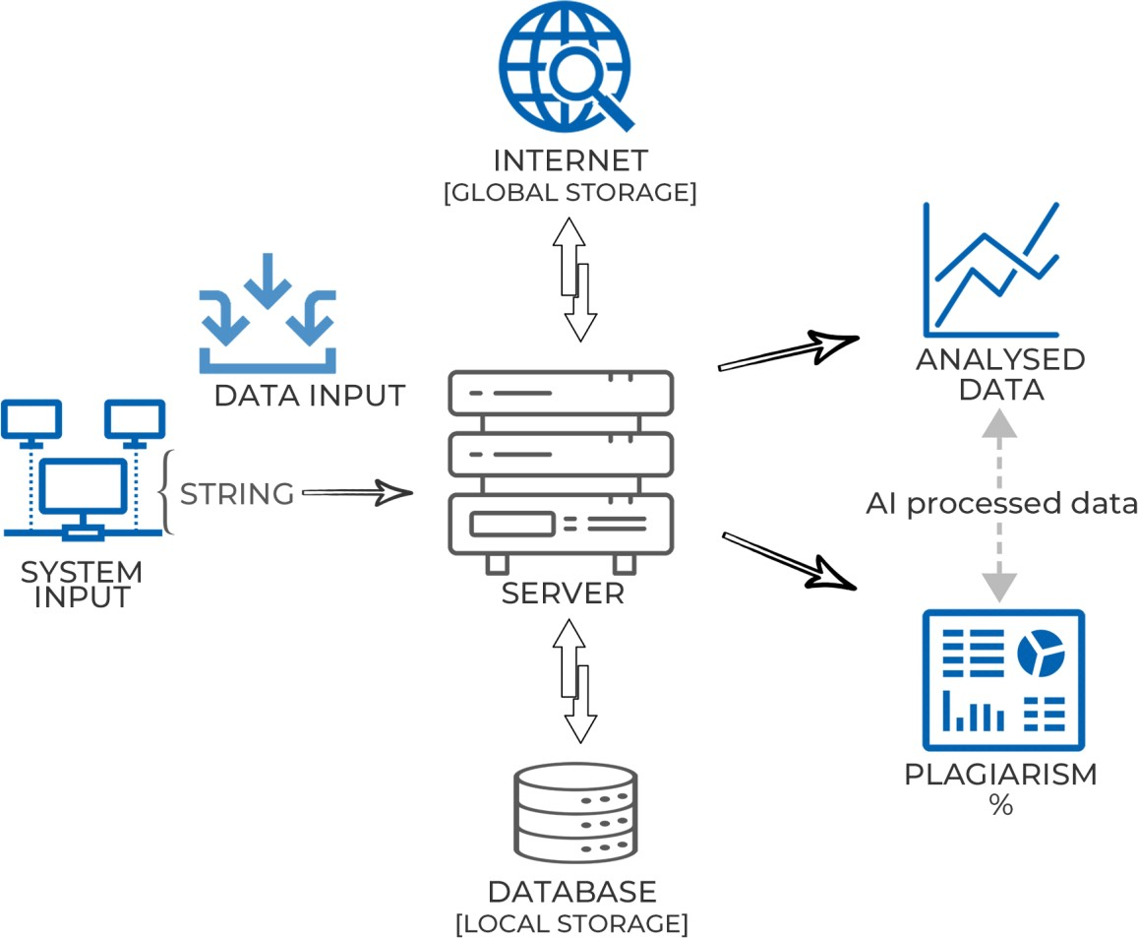
OVERALL WORKFLOW

System Groups: Multiple interconnected devices which are connected to the server. Each user is assigned a task and a device to submit that task, A user interface will be provided on which the user has to write the code( solution of the given task) and by pressing the enter button, the line will change and also the code inputted by the user will be automatically submitted and will be reflected in the local database.

This system Group acts as input machine. They provide an User interface on which the participants can write their code.

The while test area is not editable and time, plagarism percentage are all set to 0. Then to start the exam participants has to click on the start button only after that coding area will be editable. As soon as the start button is clicked the timer starts and then user has to set the language in which he/she wants to code.

All the systems are interconnected through a network, whenever a the participants press enter the code is uploaded into the local database in real-time.

Server: The server is a computer that serves information to other computers. These computers, called clients, can connect to a server through either a local area network or a wide area network, such as the internet. A server is a vital piece of your IT infrastructure.
The server collects and sends information across a network. That can be a local network, like your business network, or a wider network across multiple locations.

Any computer running the right software can be a server. Although when we hear the word server we think of enormous, high-powered machines that push and pull data across the web.

Server is a Backend architecture that saves the data coming from all the devices and checks plagiarism in the inputs submitted by the user (local database) and internet (global database).

Local Database: A local database is one that is local to your application only. It uses an SDF data file, which is SQL Server CE (Compact Edition) format. There is no need to install a server to access an SDF database. You simply distribute the DLLs that constitute SSCE along with your app and access the data file directly. It requires no configuration to run and allows for quick access to a database engine without the overhead of managing and installing a full SQL Server instance. LocalDB utilizes the minimal amount of files needed to achieve all of this. Having the database access stay local greatly reduces the complexity for developing and testing applications with a SQL Server backend.

It contains two files, one which is submitted by users and the other one which is the reference solution of the task.

Local Database is divided into two parts, the first one contains a reference solution and the second one contains a file that stores a table that contains solutions that are automatically submitted by the users. When the user press enters then the row of that particular user will be updated with the new data.

Global Database: With Global Database, users have access to complete company information across the internet and get a database which is never ending. Global Database is a collection of various websites/readable material (books) on which the solution of the task may be present.

With the help of a search engine, the server will sort the website on which the solution of the task may be present and will compare the code found on any website/readable material with the user-submitted code for each user.

Output: Server gives the output in the form of plagiarism percentage ( similarity percentage) between two and more devices/ user solutions.

If the output plagiarism percentage is greater than 30% then the solution will be categorized/ bagged as a plagiarized solution and it the output plagiarism percentage is 30% or less than 30% then the output will be categorised as a valid solution.

Compare to Moss
pure python implementation only contains one source file
no third-party dependency (except zss when using TreeDiff) no need to register an account for Moss
no need for a network to access Moss

Plagiarism detection tool with the help of python code, the basic idea is to normalize python AST representation and use difflib to get the modification from referenced code to candidate code. The plagiarism defined by this plagiarism detector is how many referenced code is plagiarized by candidate code, which means swap referenced code and candidate code will get different results.

This tool has implemented two diff methods: line based diff(UnifiedDiff) and tree edit distance based diff(TreeDiff), both of them are run in function AST level.
- UnifiedDiff, diff normalized function AST string lines, naive but efficiency.
- TreeDiff, diff function AST, very slow and the result is not good for small functions. (depends on zss) So, when running this tool in cmd, the default diff method is UnifiedDiff. And you can switch to TreeDiff when using it as a library.

DESIGN AND IMPLEMENTATION DETAILS:
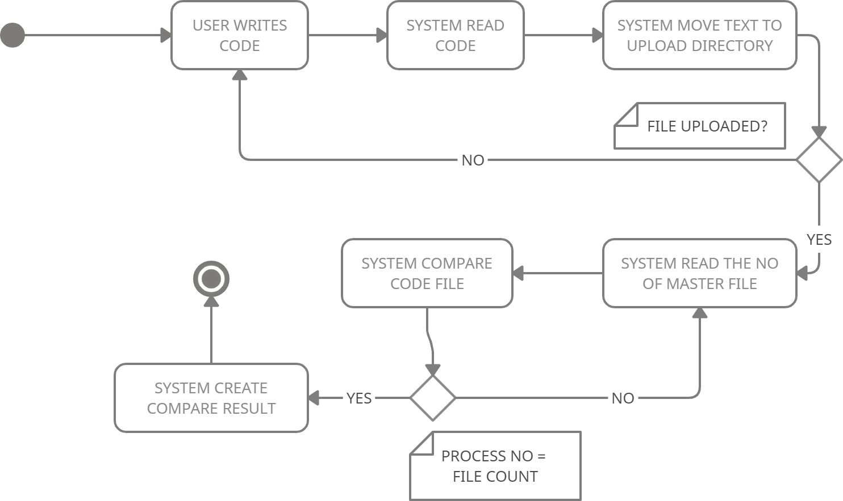

ACTIVITY DIAGRAM

WORKING FLOW: Collection of assignments: All the code will be collected in electronic format. So that plagiarism can be detected efficiently.

PRE-PROCESSING: Pre-processing is a major step in the process in which all the codes are converted into a appropriate format. All these assignments collected must be in the same format. Numbers, values.

CLASSIFICATION: Text classification should be performed to extract and separate the parts of a sentence into alternative words. With the help of this key words from a sentence can be found.

TEXT ANALYSIS: Further, the data will be passed through the text analyzing step. This process can be repeated, sometimes, according to the need. Moreover different text analyzing techniques can be used according to the nature of text and aims of the institutes.

SIMILARITY MEASURES:
Further in the process, comparison is performed upon the sequence of tri-grams created from the processed documents, with the help of sequences comparing methods.

CLUSTERING THE PLAGIARIZED DATA:

Clusters are created from the similar tri-grams to calculate the similarity score.

Clusters will help in the calculations and will accelerate the process.

PLAG PERCENTAGE:
Similarity score will be calculated through the clustering of the similar tri- grams. Similarity will be calculated in the form of percentage. High value of percentage depicts the high similarity score.
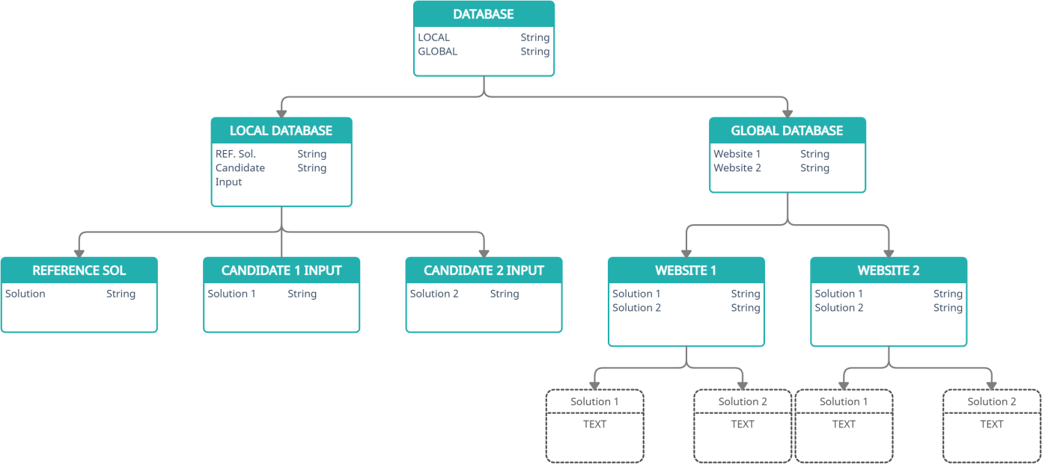

UML

STEP1: PRE-PROCESSING STAGE:

SEPARATION: In this step, the text of input document is isolated from the references mentioned therein. Separating the references from the text can be manually or programmatically. Tokenization

STEP1: Declare String array text[], text2[], Declare String line. Initialize Integer C1_text, C2_text2, sum_text, sum2_ text to 0

STEP2: Set line = in.readLine();

// to fetch line from file

STEP3: Do WHILE line is not equal to null set text[]=line.split(“ “);

// split the line based on space increment sum_text;

// sum = length of array text[]. ENDWHILE; Set next line by : line = in.readLine();

// fetch the next line Until (end of ile).

// Now, all the lines are in array text[].

STEP4:
WHILE C1_text < sum_text Set text2[C2_text2]=text[C1_text].replaceAll(“[\\W]”, “”);

// delete the delimiters Increment C1_text ENDWHILE; C2_text2=sum2_text2;

// sum2= length of array text2

STEP5: Print text2[C2_text2] // text2[]= individual words without delimiters.
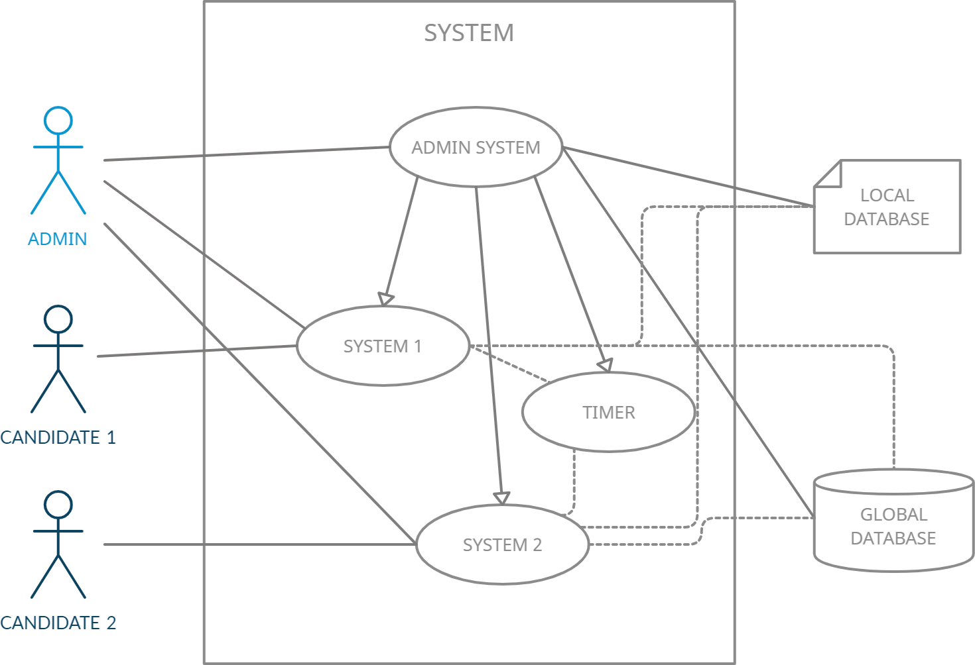

USE CASE

STOP WORDS REMOVING

Stop words are words that repeated frequently in the English language, but do not carry any information. These words may be kind of pronouns, conjunctions and prepositions. he output of this stage is a text free of stop word, initially puts all letters in lower case. Stop words that removed from the text. The output of pre-processing stage is a text ready to check against semantic plagiarism.

STEP2 : DOCUMENT DISCIPLINARY

Before detect the semantic plagiarism, a process of identifying the specialist of document is done to detect plagiarism only for documents that fall within the specialty of computer science, while the documents with other disciplines will not subject to plagiarism detection.

WORD FREQUENCY

Ater pre-processing stage, he occurrence of each word in the input document will computed according to how many times it appears in document.

DESCENDING ORDER

Frequencies that found in the previous step will arranged in descending order.

N SPECIFICATION

At this stage, N was determined within the program that representing the highest frequencies will be taken from the total number of it.

WORD (N)

Words that represent the highest (N) frequencies will take a side to reveal the correlation of source document with the computer science fields.

DECISION MAKING

Finally, the fields that are related to this document will be displayed and continue working.

STEP3: SEMANTIC PLAGIARISM DETECTION

Then, to help detecting semantic plagiarism, we propose to use semantic similarity between documents based on information extracting techniques. Semantic plagiarism will be detect based on WordNet.

TEXT

If the document passed from the threshold of specialty test of computer science, the text will be taken once again to complement this work.

WORDNET

After taking the text that was specified in the previous step, to determine the extent of the semantic plagiarism, synonyms for each word is to ind using WordNet. Every word in the specfied text will be extracted its synonyms. hense synonyms will be considered as appearance of the word itself when used to detect plagiarism.

WORDNET EXPANSION

At this stage, WordNet expansion has been proposed by speciic words doesn’t exist in its dictionary.

DOCUMENTS OF DATABASE
At this stage, the documents stored in the database will be withdrawn one after another, for these documents, the text is taken entirely not just a specific text in it, to the possibility of plagiarize a text exist in different places of database document and put it in another place of source document, these places may be abstract, results
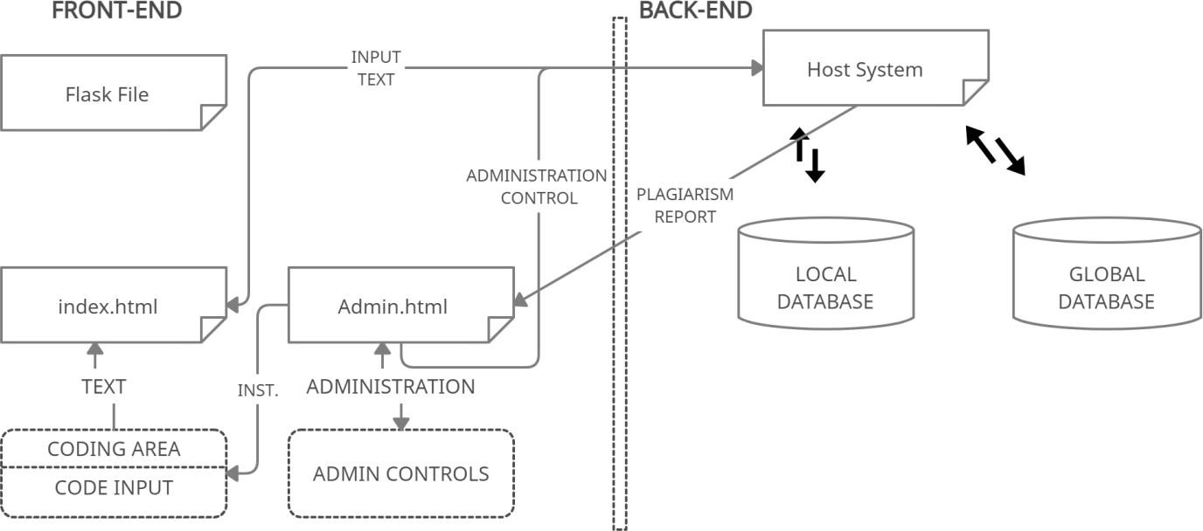

DATA FLOW DIAGRAM
RESULT
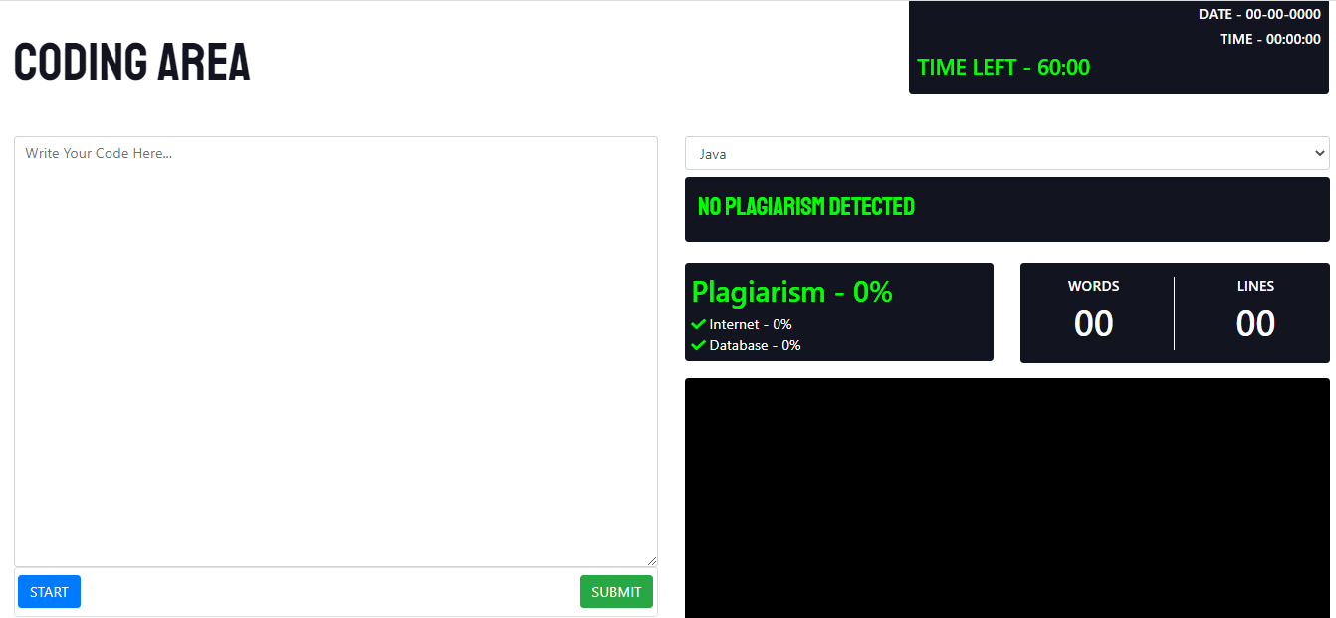

CANDIDATE PANEL SNIPPET

CODING AREA:

TEXT AREA:

The text area tag defines a multi-line text input control.

The text area element is often used in a form, to collect user inputs like comments or reviews.

A text area can hold an unlimited number of characters, and the text renders in a fixed-width font (usually Courier).

The size of a text area is specified by the <cols> and <rows> attributes (or with CSS).

TIMER:

A timer is a specialized type of clock used for measuring specific time intervals. Timers can be categorized into two main types. A timer which counts upwards from zero for measuring elapsed time

WORDS:

Number of Words typed in the code including spaces.

LINES:

Number of end Statements like : enter, semicolon, etc.

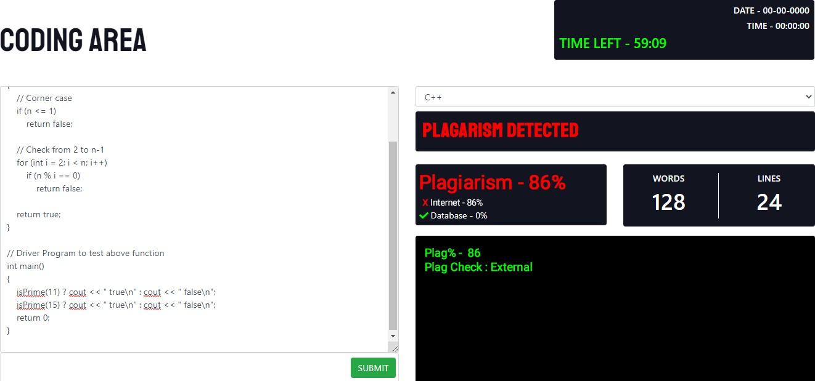

ADMIN PANEL SNIPPET

ADMIN PANEL:

The interface where administrators and other site officials with appropriate privileges can web site.
There are many tasks which can be done with the administrator interface. You can set up how your set time, candidate access etc.

PLAG %:

When the plagiarism percentage is over 80 then the system will give warning to the admin as well as candidate.

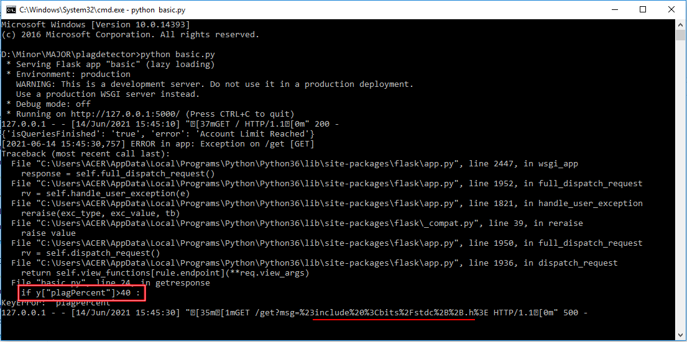

COMMAND PROMPT SNIPPET [HOST MACHINE]

COMMAND PROMPT:

It is a command line interpreter application available in most Windows operating systems. It's used to execute entered commands. Most of those commands automate tasks via scripts and batch files, perform advanced administrative functions, and troubleshoot or solve certain kinds of Windows issues.

Command Prompt is officially called Windows Command Processor, but it's also sometimes referred to as the command shell or cmd prompt, or even by its filename, cmd.exe.

All the process running on the host machine can be monitored through cmd

PLAG PERCENTAGE:

It monitors the code typed by the student line by line and extract words from the text and print them.

CONCLUSION
Plagiarism detection is essential for protecting the Coding work. It is concluded that all institutes should be aware of plagiarism and anti-plagiarism softwares. We have designed a method which assists us with the detection of instances of plagiarism in Coding Competition. Our scheme is easy to adapt for the large variety of programming languages in use, and is sufficiently robust to be highly effective in an educational environment. While having a detection rate as good as other more complex software, it presents its report as a simple Percentage, enabling large numbers of Codes to be checked simultaneously, quickly and efficiently. By using data mining algorithm, tensorflow, flask, NLP and with the use of machine learning it will provides straightforward documentation which can be used as clear and convincing evidence should a suspected instance of plagiarism be disputed.

INNOVATION AND USEFULNESS

Check plagiarism in real time.

  - Stylometry for unique writing style consideration – Stylometry is a statistical approach to plagiarism or duplicate data detection. When a plagiarism tool works with this method, it can take into account writers’ unique writing styles, including work note-taking. This allows it to determine whether a text is written by the same author or if another writer’s style has been copied. To do that, it compares segments and paragraphs of different works. Apart from plagiarism detection, this procedure is also used to ascertain the authorship of different texts to prevent conflicts in this regard.

API for fast application interaction – Application programming interface is a technology that allows different programs to communicate with each other. As long as platforms have support for this, anti-plagiarism tools can integrate with them. This way, you can implement employee blogging rules stringently because users only have to click a single button to analyze texts for possible duplicates. This also means that you do not have to copy and paste or upload files to the plagiarism checking system to conduct your analysis, thus saving you time and effort.

  - Database for accurate checks – There are now over 1.7 billion websites live on the Internet, according to Internet Live Stats. Each website itself is likely to have multiple pages that would contain texts. These, together with resources like documents uploaded to the cloud, would amount to over 60 trillion pages online across the web contained in databases.

BIBLIOGRAPHY
Software metrics and plagiarism detection,” J. Syst. Software, vol. 13 https://www.tensorflow.org/guide https://flask.palletsprojects.com/en/2.0.x/
Avoiding Plagiarism: by By Dr. Ken K. Wong U21 Global, University of Toronto

Harris R., 2004. Anti-Plagiarism Strategies for Research Papers. Retrieved January 30, 2008, from http://www.virtualsalt.com/antiplag.htm

Safe Assign, 2008. Safe Assign Anti-Plagiarism Service from Blackboard, Accessed March, 30, 2008 at http://www.safeassign.com/ Schleimer S. et al., 2003. Winno

